

Engineering Fundamentals
Edison Lascano PhD
NRC: 28434
01 Supporting evidence

Team Members
Santórum Sandoval Thais Yetsalem
Toapanta Orejuela Adrian Michael
Vargas Pérez César Alexander

Team 06 Paradigm
Topic: Clinic Management System
Leader: Thais Santórum

Supporting evidence
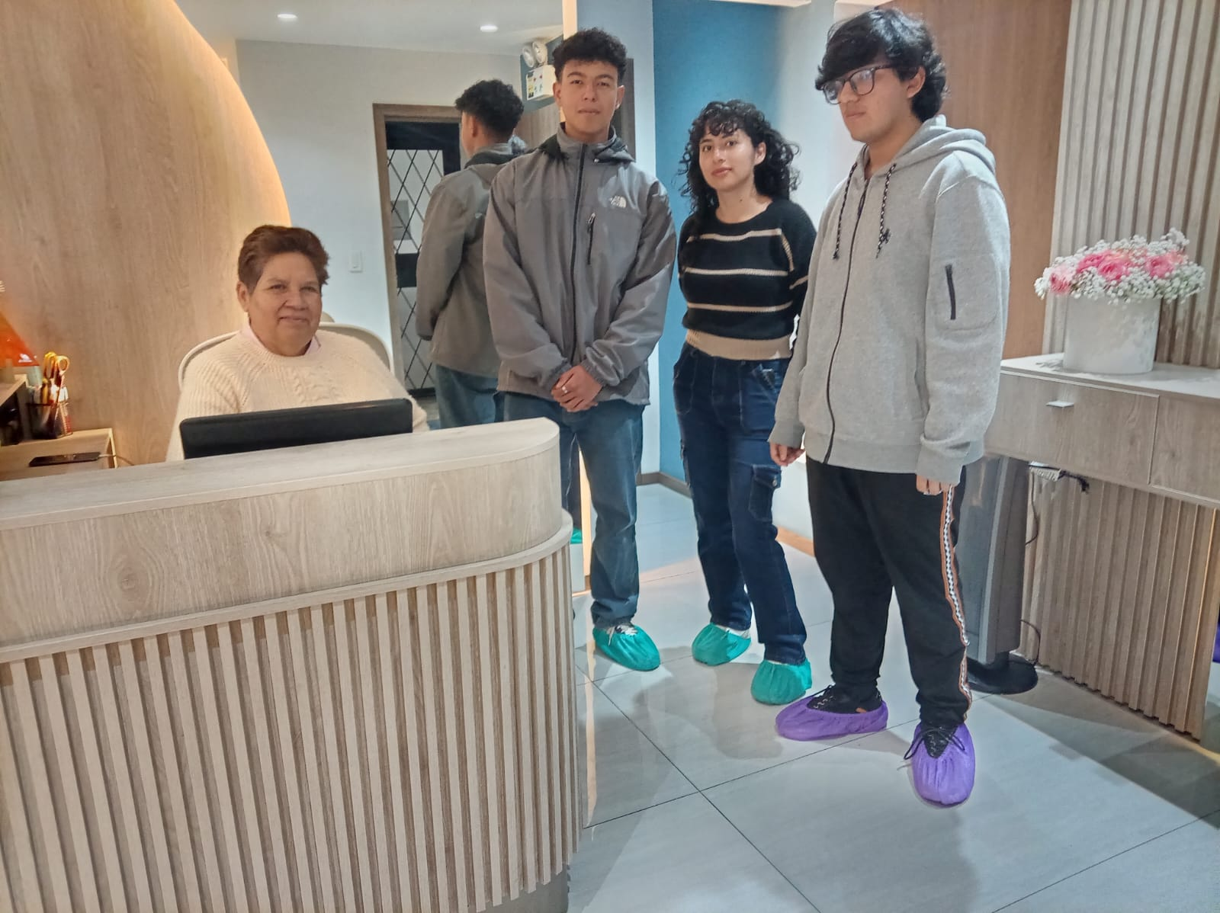
Meeting with the client at the clinic to gather requirements.

